EXPERIMENT NO. 12
Demonstration of Type-2 Hypervisor using VMware Workstation

Aim
To demonstrate virtualization by installing VMware Workstation (Type-2 Hypervisor), creating and configuring an Ubuntu virtual machine with 4 GB RAM, 20 GB virtual hard disk and 2 processors.

Objective
• Install VMware Workstation.
• Create a Virtual Machine.
• Configure RAM, processors and disk.
• Install Ubuntu as Guest OS.
• Verify successful VM creation.

Software Requirements
• VMware Workstation Pro
• Ubuntu ISO
• Windows Host OS

Theory
A Type-2 Hypervisor runs on top of a host operating system and allows multiple guest operating systems to execute simultaneously. VMware Workstation provides isolated virtual hardware for Ubuntu Linux.

Configuration
Host OS: Windows
Guest OS: Ubuntu Linux
RAM: 4 GB
Processors: 2
Virtual Disk: 20 GB
Network: NAT

Algorithm
1.Start
2.Open VMware
3.Create New VM
4.Select Linux→Ubuntu
5.Allocate 4 GB RAM
6.Set 2 processors
7.Create 20 GB disk
8.Finish
9.Power On VM
10.Stop

Procedure
1. Launch VMware Workstation.
2. Create a new virtual machine.
3. Select Linux and Ubuntu.
4. Configure 4 GB RAM.
5. Assign 2 processors.
6. Create 20 GB virtual disk.
7. Finish and power on the VM.

Observation
VMware Workstation was installed successfully. Ubuntu Linux was selected as the guest operating system. The virtual machine was configured with 4 GB RAM, 20 GB hard disk and 2 processors. The VM was created successfully and was ready for Ubuntu installation.

Result
The Type-2 Hypervisor was successfully installed and the Ubuntu virtual machine was created and configured.

Conclusion
Virtualization using VMware Workstation was demonstrated successfully.

Screenshots
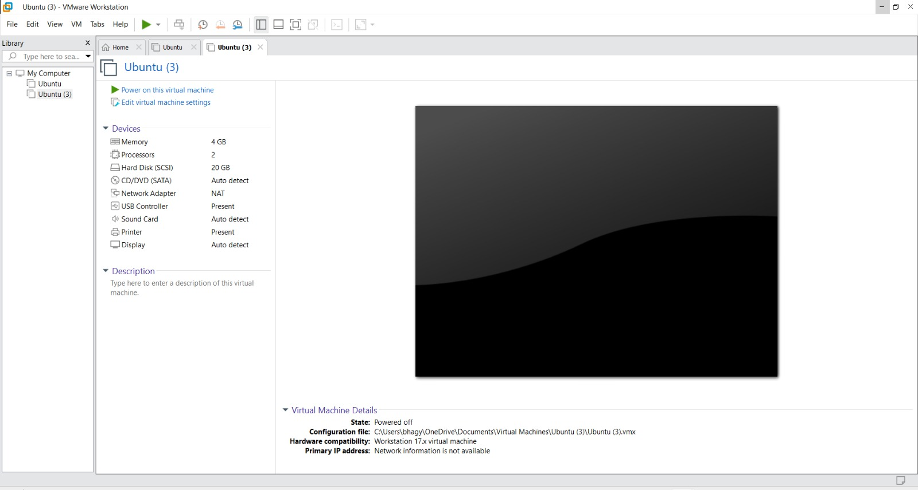
Figure 1: Ubuntu Guest OS Selection
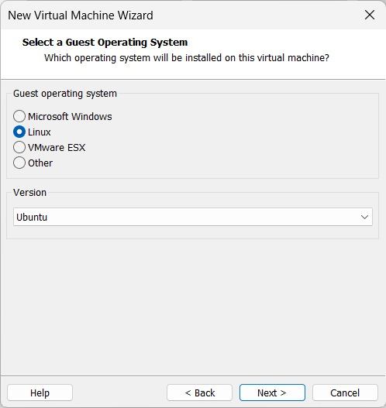
Figure 2: Configured Virtual Machine

